Self Service Mobile Application – Quick Flow Demo Card

SMA-X 2017.11

# Background

|  |  |
| --- | --- |
| Key Messages | * Intelligent Mobile self-service application – encourages employees to find a solution or guides them *to* a solution using their mobile device * Superior KM powered by the Big Data platform, yet as easy and as engaging as Facebook or Twitter * Submit a ticket quickly using an image * Approve requests from your mobile phone |
| Customer Challenge | * Users want to use their smart phones for convenience * IT can’t keep up with demand – service suffers |
| Engage Them | * Looking to reduce L1 ticket traffic? * Current Employee self-service (ESS) tool provide a mobile application? |
| Differentiators | * True Mobile application for self-service provides the user experience that modern users expect, including Push Notifications. * Expedite the Request Approval process with mobile approvals. |

# Quick Flow

The goal of the Quick Flow demo card is to provide a benefit oriented *overview*, to *introduce* the customer to value and solution. It should be completed in ~5-10 minutes; optional sub-flows to demonstrate more of the solution may be included below. Make sure your demo environment is ready – See demo preparation section at the end for initial setup. After practicing and perfecting the flow, you might want to copy and paste the right most Cheat Sheet column (below) to serve as a printed or electronic guide during the demo.

**Use Case #1: Mobile approval of a service request**

* Self-service user requests a new PC that requires their manager’s approval
* Manager receives a notification on his smartphone and approves it in the mobile application
* Self-service user can see updated status that their request has been approved.

**Use Case #2: Submit a smart ticket**

* Self-service mobile user can submit a photo easily to open a support request

**Use Case #3: Search knowledge**

* Self-service mobile user can search for solution in knowledge base

**Use Case #4: Submit a support request**

* Self-service mobile user can submit a support request

| **Do** | **Say** | **Cheat Sheet** |
| --- | --- | --- |
| **Start the Mobizen Mirroring application on your laptop to show your phone display on your laptop. Login and connect your laptop to your smartphone**  **On your smartphone, start the Service Portal application and login as joe.managermf and put it in the background.** | * For our demo, I will show you my smartphone screen on my laptop using a freeware application called Mobizen Mirroring |  |
| **Use case #1: Submit a service request with mobile approval**  *Note to presenter: This step is a replication of the Service Request and Catalog demo flow if you haven’t run it previously and left the approval pending.*   * Login in to ESS as [amy.lopezmf](mailto:amy.lopezhpe@gmail.com) and search for “Request a new PC “ * Select “(DEMO) Request a new PC” Service offering * Request the “High Performance PC” * Submit the request | * We will create a request by an employee that requires their manager’s approval which we will perform using the mobile application. | * Amy Lopez * Request a new PC * High Performance PC * Submit |
| **Push Notifications**  *Proactively notify user when their request is updated*   * Open the push notification on your smart phone (as Joe) to see the pending approval | * Proactive push notifications keep the manager informed when an approval is needed | * Mobile app as approver Joe Manager * View push notification |
| **Approvals**  *Expedite the approval process and increase convenience for the approver*   * In the mobile app, approve the request | * Approvers can approve where and when it is convenient for them. | * Approve request |
| ***Optional:* Amy sees her request has been approved**   * As Amy on your laptop, click on the link to the Request and view the status update showing the request has been approved by Joe. | * If you haven’t already seen the Self-Service portal to check the status of a request, we’ll show that now | * Optional, Amy in ESS sees updated request status for her new High Performance PC has been approved. |
| **Use Case #2: Submit a photo**   * As Joe, Press the + button to create a new request. * Press the button to submit a photo. * Enter a title: “Email on mobile won’t connect”. * In the Attachment, select a screenshot such as the email error screenshot from your Gallery or Camera and press Submit. | * The mobile application makes it very easy to submit a photo of an error message. | * Create new request (+) * Title * Submit photo image from mobile phone |
| **Use Case #3: Search knowledge**  *Users can find solutions at their convenience. No more waiting on the phone for the helpdesk.*   * Still as Joe in Service Portal mobile application * Search “Email on Mobile” | * Proactive, natural language search; language recognition algorithms. | * Search for “Email on Mobile” |
| * Results list * Quick highlight of the sources in SMA-X | * Powered by the use of Autonomy IDOL. Strength is it’s a ubiquitous search across multiple sources. * Different colored icons for specific sources that SMA-X is currently leveraging | * Results list |
| * Select the “(Demo) How to receive emails on my mobile phone” article | * Rich formatting | * Review KM article: (Demo) How to receive emails” |
| **Use Case #4: Submit a support request**  *The KM article didn’t answer solve their problem so they want to open a support request.*   * Back on the results list, select the support request: “(DEMO) Report mobile phone email connection problem.” * Fill-in description * Note that the user options are displayed (don’t have to fill in the user options as they are optional) * Select Using webmail (so manual task won’t be created) * Submit the request | * Quick submission process for the user * Support offerings are presented so that the user will select one of them and thus enter a more context specific path where automatic assignment rules can be leveraged | * Select offering “(DEMO) Report mobile phone email connection problem.” * Fill-in description * Submit |

# Demo Preparation

Demo data prep includes initial set-up tasks and items that must be checked before each demo (e.g., demo data changes over time, or to return to the pre-demo state). Be mindful of whether the changes are appropriate or needed for the demo tenant you’re using – e.g., for the shared demos, initial set-up is probably already done, and some changes shouldn’t be applied (e.g., theme)

## Initial Set-up for your private tenant:

**How to enable the mobile application for tenant?**

Go to Self-Service portal settings->Feature settings and turn on the following configuration:



The default value is Off.

## Store some error screenshots in your camera gallery on your mobile phone

Transfer some error screenshot images to the camera gallery on your phone.

  

## Install and activate the Service Portal application on your mobile phone

The Android mobile application available on the Google Play Store uses a signed certificate and can’t be used with demo systems. Therefore, a special version of the Mobile application has been provided for demo use that does not use a signed certificate. To install this version of the mobile application and use it with our SMA-X 2017.11 Shared demo system on Amazon Web Services:

1. Save the apk file to your laptop and then attach it to an e-mail that you send to yourself. If your email blocks the message due to security controls, you may have to connect your phone to your laptop via USB and transfer the file to your Download folder on your phone.
2. On your Android mobile phone, access your download folder or your email and save the APK file and then open it and install it on your mobile phone. If you are prompted to change your settings to allow installation of applications from an unknown source, you will need to allow this. The application with then require you to activate the application

1. You activate the application using one of the two options below (by scanning the QR code or entering the URL).

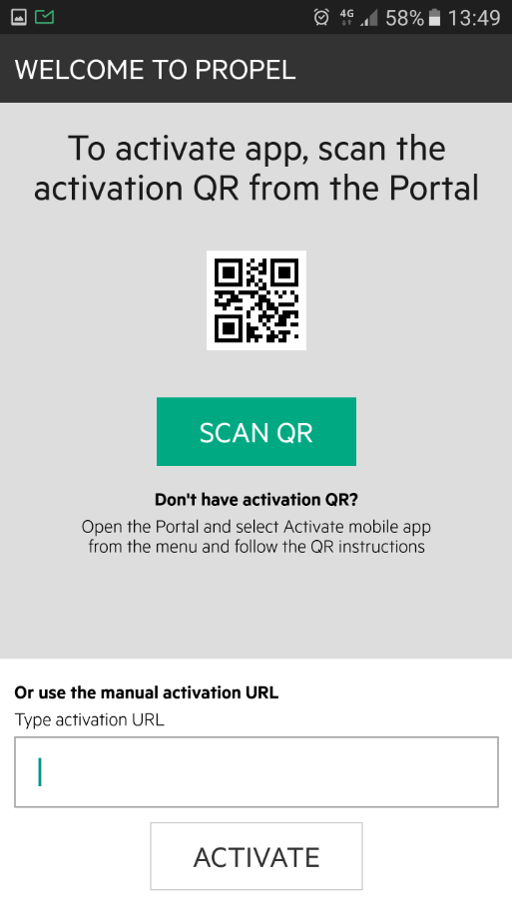

a. To scan the QR code, login to your tenant as joe.managermf (to be able to show approvals) in a browser on your laptop. Go to the Self-Service portal and select “Activate mobile application” in the upper right corner. This will display a QR code. Back on your smartphone, press the “Scan QR” button on the propel activation screen and scan the QR code on your laptop screeen. (The QR code provides the URL to your tenant).

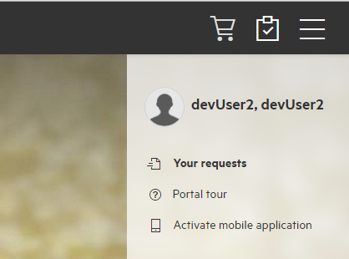 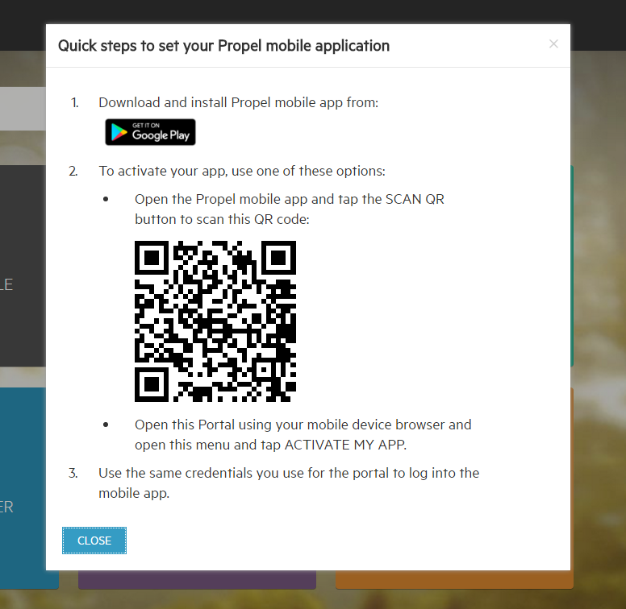

b. Or to enter the URL, paste the URL for your tenant with ‘&APP=SAW’ at the end, such as: <https://msast002pngx.saas.hp.com/?TENANTID=nnnnnnnnn&APP=SAW>

3. The mobile application will prompt you for credentials, use [joe.managermf](mailto:joe.managerhpe@gmail.com) (to show approvals). You will need to supply your credentials only once and the application will remember you.

1. Later, If you need to login to the mobile application using a different user id, then you need to clear your application data in the Service Portal application on your phone. For example, Settings > App Manager > Service Portal > Storage > Clear data

## Install the Mobizen mirroring application (to mirror your smartphone screen on your laptop)

* **On your mobile device**, go to Google Play Store > search for "mobizen mirroring" > press Install.

Note: Users with a Samsung device must search and install "Mobizen mirroring for Samsung" app.

<https://play.google.com/store/apps/details?id=com.rsupport.mobizen.cn&hl=en>

* During the Mobizen Mirroring install procedure, you will be asked to **turn on “USB Debugging”** and you need to agree to that. If don’t agree to it, you will need to do these steps to enable it:
  + <http://support-mirroring.mobizen.com/hc/en-us/articles/216761537-Where-is-USB-Debugging-located->
* During the Mobizen Mirroring install, you will not need the USB to PC software. You will connect your phone to your laptop using wireless networking.
* You will be asked to create an account using your email address and a password and then it will ask for a 2 step verification code. Next, you will install the Mobizen PC application on your laptop and there you will obtain the 2 step verification code to enter on your computer screen.
* **On your laptop**, open a browser and go to "[www.mobizen.com](http://www.mobizen.com/)".

Click on "Download Mobizen PC" icon.  
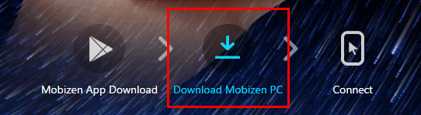

Double click on the downloaded file and follow the on-screen instruction to finish the installation.

***For Windows:***[***https://download.mobizen.com/download/mobizen.exe***](https://download.mobizen.com/download/mobizen.exe)

***For Mac :***[***https://download.mobizen.com/download/mobizen.pkg***](https://download.mobizen.com/download/mobizen.pkg)

## Using the Mobizen mirroring application for the first time (to mirror your smartphone screen on your laptop)

Start the Mobizen application on your smart phone and press the 2-Step verification button.

On your laptop, start the RSUPPORT > Mobizen> Mobizen application, (create an account), and the verification code will be displayed that you need to enter on your smartphone. If you are asked to install Bonjour to mirror an Ipad/Iphone screen, you can select the android symbol at the top and skip the install Bonjour step.

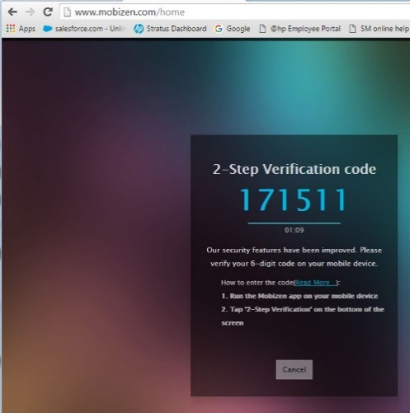

Enter the verification code on your smartphone and check the checkbox on the smartphone app “Do not ask again for this PC” to always trust this PC so you don’t have to use two-factor verification in the future.

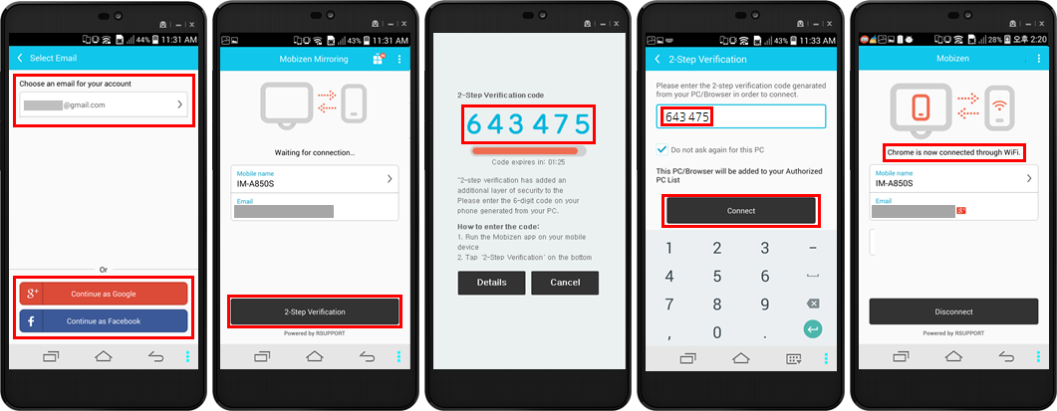

After that, anything shown on your smartphone will display in the Mobizen application on your laptop.

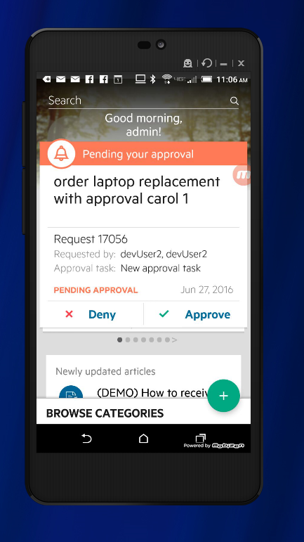

If you need to switch your user ID in the mobile client, you will need to clear the data in the Service Portal application in the App Manager under Settings on your Android phone. For example,

Settings > App Manager > Service Portal > Storage > Clear data

## Using the Mobizen mirroring application each time you demo (to mirror your smartphone screen on your laptop)

*See the Demo preparation section above for installation and first time use instructions.*

On your laptop, start the RCONNECT>Mobizen>Mobizen application or connect to <http://www.mobizen.com> and login to your account. Your smartphone display should now be visible on your laptop in the browser window. *Note that a wi-fi connection is used to connect from the Smartphone to the PC.*

If you have not enabled your smartphone to trust this PC, you will have to provide the 2-step verification code each time you connect.